


目录
H5Player WEB SDK Development Guide
1 Overview 6
1.1 Technology Introduction 6
1.2 Supported Devices 6
1.3 Running Environment 7
1.4 Decoding Performance 8
2 Installation 11
2.1 Loading Files 11
2.2 Running Directly 11
2.3 Running Across Domains 11
3 Starting Program 13
3.1 Starting nginx 13
3.2 Creating Playback Tag 15
3.3 Creating Playback Instance 15
4 API 17
4.1 Logging in to the Device 17
4.2 Initialization 18
4.3 Playback and Control 18
4.3.1 Connecting to Device 18
4.3.2 Starting Playback 19
4.3.3 Pausing Playback 19
4.3.4 Resuming Playback 20
4.3.5 Playing Video at Specific Time 20
4.3.6 Stopping Playback 21
4.3.7 Setting Volume 21
4.3.8 Taking Snapshot 22
4.3.9 Adding Event 23
4.4 Voice Intercom 23
4.4.1 Enabling Intercom 23
4.4.2 Disabling Intercom 24
4.5 Video Recording 24
4.5.1 Starting Video Recording 24
4.5.2 Stopping Video Recording 25
4.5.3 Cropping Video 25
4.5.4 Downloading Video 28
4.6 PTZ Control 28
4.6.1 Rotating PTZ 28
4.6.2 Preset Operation 29
4.6.3 Zoom and Focus 31
4.7 Image Amplification 32
4.7.1 Enabling Digital Zoom 32
4.7.2 Disabling Digital Zoom 33
4.7.3 Setting Full Screen 34
4.7.4 Canceling Full Screen 34
4.8 Events 35
4.8.1 Adding Event 35
5 Events 35
5.1 Completing File Loading 35
5.2 Starting Decoding 36
5.3 Starting Playing 37
5.4 Changing Resolution 37
5.5 Changing Video Encoding Mode 38
5.6 Changing Audio Encoding Mode 39
5.7 Obtaining Total Video Duration 40
5.8 Obtaining Video File Timestamp 40
5.9 Playing a New Frame 41
5.10 Completing Playing the Current Video 42
5.11 Playback Error 43
6 Error Codes and Description 44
6.1 Error Codes and Description 44

1 Overview

1.1 Technology Introduction
H5Player uses the WebSocket channel and transmits audio and video signaling and data through the RTSP/RTP Dahua package protocol. WebSocket is the expressway, RTSP/RTP is the truck moving on the expressway, and audio and video signaling and data are the goods in the truck. The client (browser) first establishes a Websocket connection to the device, and then initiates relevant signaling. After the device returns data, the client obtains the data and performs video and audio decoding and playback through MSE technology and Dahua decoding library.

1.2 Supported Devices
Most Dahua IPCs and PTZ cameras support audio and video live view and playback by using H5Player (without plug-ins). See the following for details.
1. All Dahua IPCs and PTZ cameras with web 5.0 support H5Player.
2. For Dahua IPCs and PTZ cameras with web 3.0, check whether they support H5Player in the following ways.
Enter the IP address in the Google Chrome 45 and later versions.
Log in to the device to go to the live view page.
Press the F12 key, switch to the console in the devtools toolbar, and then enter webCaps.isShowCanvasPlayer. If the result is 1 or true, it means the device supports H5Player. Otherwise, it means H5Player is not supported.
See the following figure.

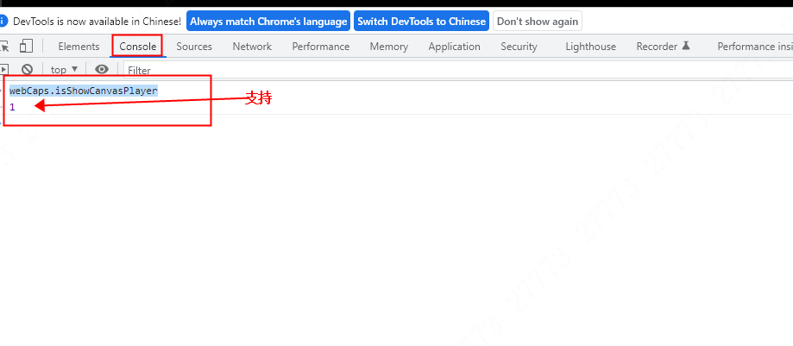

support

1.3 Running Environment
H5Player WEB SDK must run in web containers (such as Tomcat, Apache, IIS, Nginx, etc.)
When you access it with the client, the following software environments are supported:
Windows XP, Windows7, Windows10, Windows11, Chrome65+, FireFox65+, Edge79+, and MAC OS Safari15+.

1.4 Decoding Performance
Decoding Performance
1.4.1 Supported Browsers

Supported Browsers
Browser | Chrome | Firefox | Edge | Safari | Others
Version | 65+ | 65+ | 79+ | Mac OS Safari15+ | O
Support | O | O | O | O | X

1.4.2 Supported Maximum Stream

Supported Maximum Stream
Encode Mode | H264 | H265 | MJPEG
Supported Maximum | 4000*3000,25FPS | 2560*1440,25FPS | 1920*1080,25FPS

1.4.3 Delayed Report

H264 Delayed Report
Encode Mode | H264 | H264 | H264
Bit Rate | 1920*1080,25FPS | 2560*1440,25FPS | 4000*3000,25FPS
Maximum Delayed | 700ms | 700ms | 700ms

H265 Delayed Report
Encode Mode | H265 | H265 | H265
Bit Rate | 1280*720,25FPS | 1920*1080,25FPS | 2560*1440,25FPS
Maximum Delayed | 300ms | 600ms | 900ms

1.4.4 Supported Multiple Channels

Supported Multiple Channels
Encode Mode | H264 | H264 | H264
Bit Rate | 1280*720,15FPS | 1280*720,25FPS | 1920*1080,25FPS
Channels | 12 | 12 | 9

Supported Multiple Channels
Encode Mode | H265 | H265 | H265
Bit Rate | 704*576,25FPS | 1280*720,25FPS | 1920*1080,25FPS
Channels | 12 | 6 | 4

1.4.5 Supported Audio Format by Browser

Supported Audio Format by Browser
Encode Mode | Chrome | Firefox | Edge | Safari
PCM | X | X | X | X
G.711A | O | O | O | O
G.711mu | O | O | O | O
G.726 | O | O | O | O
AAC | O | O | O | O

Note: The data above is based on the following environments.
Client software environment: Win10 and Chrome92.
Client hardware environment: CPU i5 10210U, 16 GB memory.

2 Installation

2.1 Loading Files
Before using H5Player WEB SDK to pull streams, you need to load related files because ES5 is currently used.
<script src="module/PlayerControl.js"></script>
The class open to external interfaces is PlayerControl.

2.2 Running Directly
If you only need the following functions (API in the directory), you do not need to log in to the device and do not need the forwarding service of nginx. You can directly call the PlayerControl interface.
1. Play and control
2. Audio and talk
3. Video recording
4. Image amplification
5. Event

2.3 Running Across Domains
To perform PTZ operations, you need to log in to the device and need proxy forwarding supported by the http server. The following section uses nginx as an example to describe PTZ operations.
The PTZ operation of the WEB SDK is an http request which is limited by cross-domain browser restrictions and cannot be accessed directly. Therefore, you need http proxy. H5Player WEB SDK can use the proxy service provided by nginx, or you can configure the proxy based on your own http server. The proxy configuration is as follows:
In the http request header, add self-tragetIp:device IP (the IP address of the device on which you want to perform PTZ operations).
In the web server, complete the following configuration (take nginx as an example):
In the nginx-1.10.2/conf/ nginx.conf file, modify as follows:
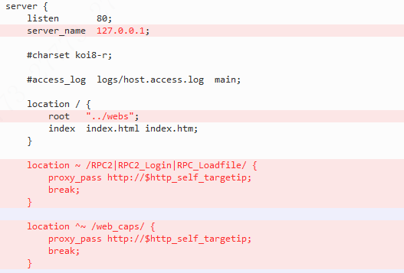

3 Starting Program

3.1 Starting nginx
You can directly click start.bat in the nginx-1.10.2 folder to start nginx. For more information about how to build services in Linux, see Build a Nginx Environment_Linux. Docx.
After starting nginx, open the browser and access http://127.0.0.1/ to enter the following interface.

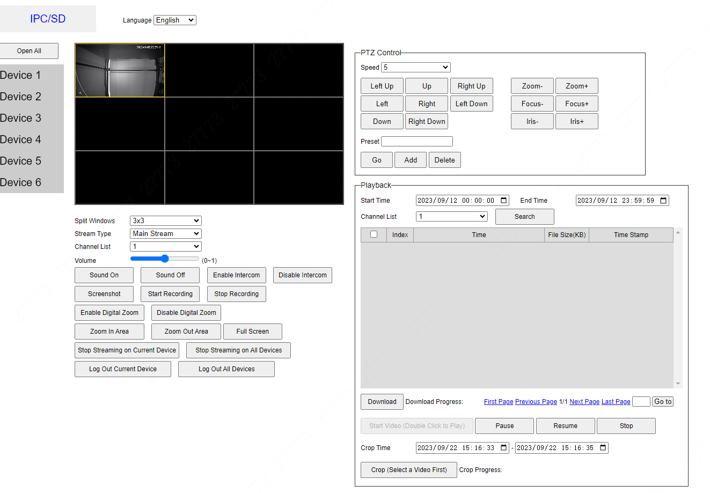
Note: Nginx of H5Player WEB SDK uses Port 80. Make sure that Port 80 is idle before starting nginx service.
To stop the program, double-click stop.bat.

3.2 Creating Playback Tag
When you integrate H5Player WEB SDK into your development environment, you need to create the playback html element on the page, which is used to display videos.
H5Player WEB SDK use canvas and video elements to play videos in different encoding modes.
Because H5Player plays the corresponding videos through the H5 video and canvas tag (H264 uses video. When H265 or AI coding is enabled, it uses canvas), we need to create a tag. first
<video id="testVideo"></video>
<canvas id="testCanvas"></canvas>
After the playback starts, H5Player WEB SDK returns a playback mode through the event, which displays whether to play in video or in canvas. You only need to set the corresponding video or canvas as display. This will be described in details in the Events section.

3.3 Creating Playback Instance
H5Player WEB SDK uses the following methods to create a playback instance.
var options = {
wsURL: 'ws://172.23.2.100:80/rtspoverwebsocket',
rtspURL: 'rtsp://172.23.2.100:80/cam/realmonitor?channel=1&subtype=0&proto=Private3',
username: 'admin',
password: 'admin123'
};
var videoplayerObj = document.getElementById('testVideo');
var canvasplayerObj = document.getElementById('testCanvas');
var player = new PlayerControl(options);
player.init(canvasplayerObj, videoplayerObj); //Initialize the player
The options are defined as follows:
Property Name | Description
wsURL | The websocket protocol address, which is used when connecting to the websocket service. If the device uses https, the wss protocol is also used.
rtspURL | The RTSP protocol address, which cannot be modified except for channel and subtype. subtype indicates the stream type (0: main stream, 1: sub stream 1, 2: sub stream 2).
username | The username. The username and password are required because authentication is required for RTSP stream pulling.
password | Password.
Note
The websocket protocol address is the URL provided by the server. If it is a front-end device such as IPC and PTZ camera, the address is generally IP:port/rtspoverwebsocket. For NVR, platform and other products, consult the corresponding service provider.
Similar to the websocket, the rtspURL protocol address is also provided by the server. H5Player WEB SDK player is only a client, which needs to know media information before playing it.
For example, if you want to access Dahua Portal through a browser client, you need to know the URL of Dahua Portal is www.dahuatech.com.
At this point, you can call various APIs of the player instance to perform relevant operations.
For example, to perform post-instanced playback, use the following methods.
Establish a connection and play by calling the connect method.
player.on('WorkerReady',function(){//Start pulling streams after files are ready.
player.connect();
});
WorkerReady is triggered when files are loaded for playback, the event is triggered. This will be described in detail the Events section.
Now, you can see the video on the image.

4 API
 | 4.1 Logging in to the Device
 | RPC.login
 | Definition and Usage
 | RPC.login is used to log in to the device. To perform PTZ operations, you need to log in to the device.
 | Default Value | No default value
 | JavaScript Syntax | RPC.login(name, pswd, false)
 | Parameters
 | Parameter | Description
 | name | Username
 | pswd | Password
 | false | Fixed to false
 | Return Value
 | promise object
 | 4.2 Initialization
 | init
 | Definition and Usage
 | Used to initialize the H5Player player. This method must be called.
 | Default Value | No default value
 | JavaScript Syntax | player.init(canvasElem, videoElem)
 | Parameters
 | Parameter | Description
 | canvasElem | This parameter is required. The original dom object is used to play videos in H265 playback mode.
 | videoElem | This parameter is required. The original dom object is used to play videos in H264 playback mode.
 | Return Value
 | None

 | 4.3 Playback and Control
 | 4.3.1 Connecting to Device
 | connect
 | Definition and Usage
 | connect is used to initiate a websocket connection with the device and start playing audio and video.
 | Default Value | No default value.
 | JavaScript Syntax | player.connect()
 | Parameter
 | No parameters
 | Return Value
 | None

 | 4.3.2 Starting Playback
 | play
 | Definition and Usage
 | play is used to resume the play after it is paused.
 | Default Value | No default value.
 | JavaScript Syntax | player. play()
 | Parameters
 | No parameters
 | Return Value
 | None

 | 4.3.3 Pausing Playback
 | pause
 | Definition and Usage
 | pause: This method pauses playing audio and videos and only supports playback.
 | Default Value | No default value.
 | JavaScript Syntax | player. pause()
 | Parameters
 | No parameters
 | Return Value
 | None

4.3.4 Resuming Playback
For more information about how to resume playback, see 4.3.2.

 | 4.3.5 Playing Video at Specific Time
 | playByTime
 | Definition and Usage
 | Move to the specified time point to play the video. Only playback is supported.
 | Default Value | No default value.
 | JavaScript Syntax | player.playByTime(range)
 | Parameters
 | Parameter | Description
 | range | Required. Integer used to specify the time point to play the video, in seconds.
 | Return Value
 | None

 | 4.3.6 Stopping Playback
 | stop
 | Definition and Usage
 | Stop pulling the stream. TEARDOWN signaling is initiated to the device, but the websocket connection is not disconnected.
 | Default Value | No default value.
 | JavaScript Syntax | player. stop()
 | Parameters
 | No parameters
 | Return Value
 | None
 | close
 | Definition and Usage
 | Close stream pulling to stop pulling the stream, disable the websocket connection and stop the related worker. To play the video again, you need to complete initialization again.
 | Default Value | No default value.
 | JavaScript Syntax | player.close()
 | Parameters
 | No parameters
 | Return Value
 | None

 | 4.3.7 Setting Volume
 | setAudioVolume
 | Definition and Usage
 | Adjust the volume in the range of 0-1.
 | Default Value | No default value.
 | JavaScript Syntax | player.setAudioVolume(val)
 | Parameters
 | Parameter | Description
 | val | Volume. Range: 0–1.
 | Return Value
 | None
 | Note: To disable audio, set the val parameter to 0. When videos or audio is played through WEB SDK, the default volume is 0. If audio is required, you must call this method and the parameter is greater than 0.

 | 4.3.8 Taking Snapshot
 | capture
 | Definition and Usage
 | Capture an image of the current video.
 | Default Value | No default value.
 | JavaScript Syntax | player.capture(fileName)
 | Parameters
 | Parameter | Description
 | fileName | The name of the image to be saved must conform to the file name naming format.
 | Return Value
 | None

 | 4.3.9 Adding Event
 | on
 | Definition and Usage
 | Add events to the player. For more information about event types, see the Events section.
 | Default Value | No default value.
 | JavaScript Syntax | player.on(eventName, callback)
 | Parameters
 | Parameter | Description
 | eventName | Event name. An enumerated value. Only fixed events are supported. For more information about event names and descriptions, see the next section.
 | callback | Callback function, which is called when an event is triggered. If there is a return value, the return Value is represented in the parameters of the callback function.
 | Return Value
 | None

 | 4.4 Voice Intercom
 | 4.4.1 Enabling Intercom
 | talk
 | Definition and Usage
 | Enable or disable voice intercom.
 | Default Value | No default value.
 | JavaScript Syntax | player.talk(status)
 | Parameters
 | Parameter | Description
 | status | The enumerated value. The string on indicates that the intercom is enabled. Other values, such as off, indicate that the intercom is disabled.
 | Return Value
 | None

4.4.2 Disabling Intercom
For more information on how to disable the intercom, refer to 4.3.1. You only need to change the talk parameter to a value other than on.

 | 4.5 Video Recording
 | 4.5.1 Starting Video Recording
 | startRecord
 | Definition and Usage
 | Enable or disable local video recording.
 | Default Value | No default value.
 | JavaScript Syntax | player.startRecord(bool)
 | Parameters
 | No parameters
 | Return Value
 | None
 | Note: The functions of enabling and stopping video recording are in pairs, and the video recording must be turned on before it can be stopped. When the video recording is stopped, the browser will open the download window and save the videos to the local hard disk.

4.5.2 Stopping Video Recording
Please refer to 4.5.1 for how to stop video recording. You only need to change the parameters of startRecord to false.

 | 4.5.3 Cropping Video
 | startCut
 | Definition and Usage
 | Cut a clip from a video according to the time.
 | Default Value | No default value.
 | JavaScript Syntax | player.startCut(bool)
 | Parameters
 | Parameter | Description
 | bool | Boolean. When the parameter is true, the video cropping starts. When the parameter is false, the video cropping is complete.
 | Return Value
 | None
Note: Video cropping is a complex function. A complete video cropping function is as follows:
- Initialize a WEB SDK.
- The ws and rtsp address of the video.
- Set the time period (start time and end time) for the video to be cropped.
- Perform the cropping operation.
- When the data stream is transmitted to the end frame, the cropping operation is complete.
 | For the complete sample, see the following figure:
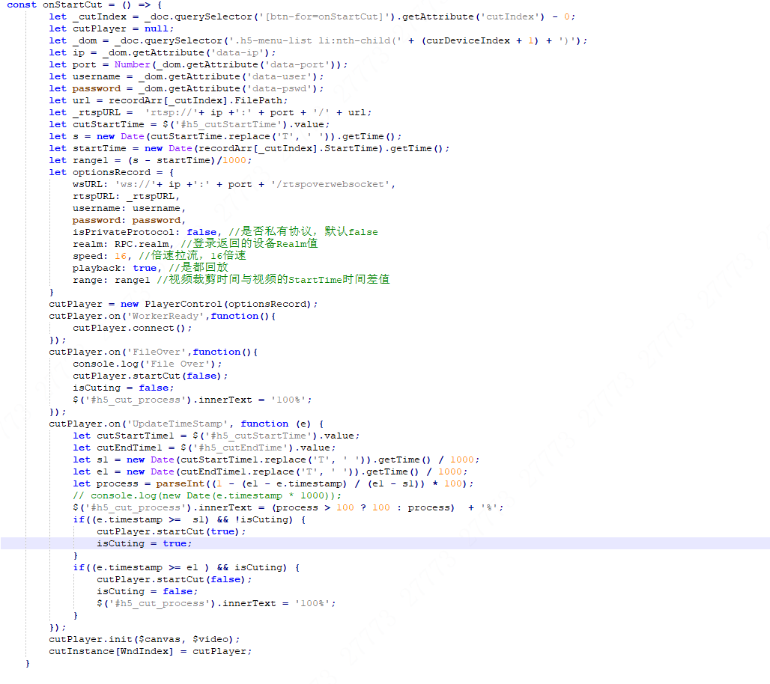
The parameters required for video cropping are similar to video playback.
Connect to the device.
If the end date of the cropping setting is still larger than the video duration, it will be automatically cropped to the end of the video by default.
Clipping time period

When the time of the code stream data is after the end cropping time, the cropping action ends.
When the time of the stream data is after the start cropping time, the cropping action starts.
crop at the fastest speed. You can change the value to a value between 1 and 16 based on the network conditions.

4.5.4 Downloading Video
The principle of video download is the same as that of video cropping. The difference is that video download does not transmit the start time and end time. Refer to the video cropping function.

 | 4.6 PTZ Control
 | 4.6.1 Rotating PTZ
 | To rotate the PTZ, you need to successfully log in to the device.
 | onHandlePTZ
 | Definition and Usage
 | Rotate the PTZ to adjust the device image. You can rotate the PTZ in eight directions. Enter an integer between 1 and 8 in the speed input box and click the relevant button.
 | Default Value | No default value.
 | JavaScript Syntax | You can call this when the onmousedown and onmouseup events are defined in the window. window.onHandlePTZ = function(type, isStop) {...... }
 | Parameters
 | Parameter | Description
 | type | PTZ rotation directions: Left, Upper Left, Up, Upper Right, Right, Lower Left, Down, Lower Right.
 | isStop | The bool type. Specifies whether to stop rotation. Set the value to false for onmousedown events and true for onmouseup events.
 | Return Value
 | None
 | RPC.PTZManager
 | Definition and Usage
 | RPC protocol to control PTZ operations.
 | Default Value | No default value.
 | JavaScript Syntax | RPC.PTZManager(action, channel, { 'code': type, 'arg1': arg1, 'arg2': arg2, 'arg3': arg3 })
 | Parameters
 | Parameter | Description
 | action | start or stop
 | channel | Channel
 | type | Left, LeftUp, Up, RightUp, Right, LeftDown, Down, RightDown
 | arg1 | Speed (vertical), 1–8
 | arg2 | Speed (horizontal), 1–8
 | arg3 | 0 by default.
 | Return Value
 | None

 | 4.6.2 Preset Operation
 | To perform operations on presets, you need to successfully log in to the device.
 | onHandlePTZ
 | Definition and Usage
 | Rotate the PTZ to adjust the device image. You can view, add, and delete the preset by number. Enter a positive integer in the preset input box and click the relevant button.
 | Default Value | No default value.
 | JavaScript Syntax | Defined in window. Call this for onclick event. window.onHandlePTZ = function(type, isStop) {...... }
 | Parameters
 | Parameter | Description
 | type | GotoPreset (view preset), SetPreset (set preset), and ClearPreset (delete preset).
 | isStop | The bool type. Default value: false. You do not need to modify it.
 | Return Value
 | None
 | RPC.PTZManager
 | Definition and Usage
 | RPC protocol to control PTZ operations.
 | Default Value | No default value.
 | JavaScript Syntax | RPC.PTZManager(action, channel, { 'code': type, 'arg1': arg1, 'arg2': arg2, 'arg3': arg3 })
 | Parameters
 | Parameter | Description
 | action | Start
 | channel | Channel
 | type | GotoPreset, SetPreset, ClearPreset.
 | arg1 | Preset value
 | arg2 | Preset value
 | arg3 | 0 by default.
 | Return Value
 | None

 | 4.6.3 Zoom and Focus
 | To zoom and focus on the image ,you need to successfully log in to the device,
 | onHandlePTZ
 | Definition and Usage
 | Adjust the device image. Adjust the zoom, focus and iris of the device. Enter an integer 1-8 in the speed input box and click the relevant button.
 | Default Value | No default value.
 | JavaScript Syntax | Defined in window. Call this for onmousedown and onmouseup events. window.onHandlePTZ = function (type, isStop) {}
 | Parameters
 | Parameter | Description
 | type | ZoomWide (zoom-)，ZoomTele (zoom+)，FocusFar (focus-)，FocusNear (focus+)，IrisSmall (iris-)，IrisLarge (iris+).
 | isStop | The bool type. Specifies whether to stop the adjustment. Set the value to false for onmousedown events and true for onmouseup events.
 | Return Value
 | None
 | RPC.PTZManager
 | Definition and Usage
 | RPC protocol to control operations on the image.
 | Default Value | No default value.
 | JavaScript Syntax | RPC.PTZManager(action, channel, { 'code': type, 'arg1': arg1, 'arg2': arg2, 'arg3': arg3 })
 | Parameters
 | Parameter | Description
 | action | start or stop
 | channel | Channel
 | type | ZoomWide, ZoomTele, FocusFar, FocusNear, IrisSmall, IrisLarge
 | arg1 | Speed (times).
 | arg2 | 0 by default.
 | arg3 | 0 by default.
 | Return Value
 | None

4.7 Image Amplification

4.7.1 Enabling Digital Zoom
The principle of digital zoom is to draw a rectangular frame on the image through canvas to obtain the size of the rectangular frame. Through a specific proportion algorithm, a new height x and width value y are obtained, set the height and width of the dom node of the current video to x and y, and then digital zoom can be realized.
Use digital zoom through the the following steps.
1、In the [start decoding] event of the video play instance, add an image drawing instance and assign a callback function to the drawing instance. When an image is drawn on the interface, the callback function is executed and the parameter is the coordinate point of the image.
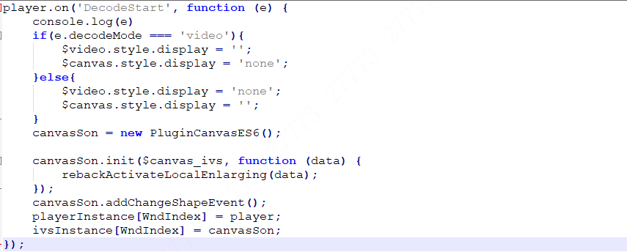
Initialize a drawing instance
Register a callback function. When the graph is drawn, call the function and return the graph coordinate points.

2、rebackActivateLocalEnlarging calculates the multiple of digital zoom according to the coordinates returned in the previous step, and performs video amplification operations.
3、After the onStartEnlarge method is executed, a rectangle can be drawn on the interface, that is, the setting of the digital zoom area. When the drawing is complete, the second step will be performed.

4.7.2 Disabling Digital Zoom
To disable digital zoom, you only need to restore the video size to the default value. Follow these steps to disable digital zoom.

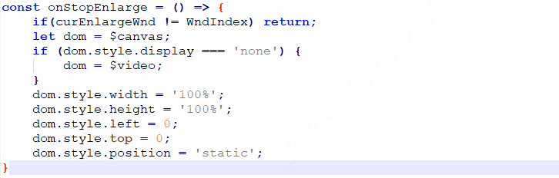
The playdom node(canvas or video), which is set to the initial size.

 | 4.7.3 Setting Full Screen
 | setfullScreen
 | Definition and Usage
 | Set the full screen.
 | Default | No default value.
 | JavaScript Syntax | setfullScreen()
 | Parameters
 | No parameters
 | Return Value
 | None
 | 4.7.4 Canceling Full Screen
 | exitfullScreen
 | Definition and Usage
 | Cancel the full screen.
 | Default | No default value.
 | JavaScript Syntax | exitfullScreen()
 | Parameters
 | No parameters
 | Return Value
 | None

 | 4.8 Events
 | 4.8.1 Adding Event
 | on
 | Definition and Usage
 | Add events to the player. For more information about event types, see events.
 | Default | No default value.
 | JavaScript Syntax | player.on(eventName, callback)
 | Parameters
 | Parameter | Description
 | eventName | Event name, an enumerated value. Only fixed events are supported. For more information about event names and descriptions, see the next section.
 | callback | Callback function, which is called when an event is triggered. If there is a return value, the return value is represented in the parameters of the callback function.
 | Return Value
 | None

5 Events

5.1 Completing File Loading
WorkerReady
Definition and Usage
This event is triggered when all files are loaded.
JavaScript Syntax
player.on('WorkerReady', function(){
player.connect();
});

Some codes of H5Player WEB SDK is loaded asynchronously. If the H5Player WEB SDK is not loaded, a connection is established with the device to pull the stream, which may cause playback failure. Therefore, you must wait until the WorkerReady is triggered before you can connect to the device. Otherwise, playback may fail.

5.2 Starting Decoding
DecodeStart
Definition and Usage
The event is triggered when the decoder starts decoding.
JavaScript Syntax
player.on('DecodeStart', function(rs){
console.log(rs);
});
The event will pass the rs result to the callback function. The rs is a result set. For more information, see the following table.

Property Name | Remarks
width | Width of the current video.
height | Height of the current video.
decodeMode | The current video is played in canvas or video mode.
encodeMode | Current video encoding mode.

The following is an example of the returned result:
decodeMode: "canvas"
encodeMode: "h265"
height: 720
width: 1280

5.3 Starting Playing
PlayStart
Definition and Usage
This event is triggered when the player starts playing a video.
JavaScript Syntax
player.on('PlayStart', function(){
// Hide the loading icon.
});

5.4 Changing Resolution
MSEResolutionChanged
Definition and Usage
When the video resolution changes, the event is triggered.
JavaScript Syntax
player.on('MSEResolutionChanged ', function(rs){
console.log(rs);
});
When the H5Player library parses each frame, it determines whether the resolution of the current frame is consistent with that of the previous frame. If the resolution changes, the event is triggered. When a user changes the resolution, all clients that open H5Player to play videos will trigger the event.
The event passes the rs result to the callback function. The rs is a result set. For more information about the result set, see the following table.

Property Name | Remarks
width | Width of the current video.
height | Height of the current video.
decodeMode | The current video is played in canvas or video mode.
encodeMode | Current video encoding mode.

The following is an example of the returned result. The returned result is an example when you switch from 720p to 1080p:
decodeMode: "canvas"
encodeMode: "h265"
height: 1080
width: 1920

5.5 Changing Video Encoding Mode
FrameTypeChange
Definition and Usage
An event is triggered when the video encoding mode is changed.
JavaScript Syntax
player.on('FrameTypeChange', function(){
console.log(rs);
});

When the H5Player library parses each frame, it determines whether the video encoding mode of the current frame is the same as that of the previous frame. If the video encoding mode changes, the event is triggered. When a user changes the video encoding mode, all clients that enable H5Player to play the video will trigger the event.
After the video encoding mode is changed, the video playback is interrupted and cannot be restored. Therefore, the stream must be pulled again. In the callback of this event, the previous stream is closed and the stream is pulled again. The parameter of the callback function is the changed video encoding mode.

5.6 Changing Audio Encoding Mode
audioChange
Definition and Usage
When the audio encoding mode is changed, the event is triggered.
JavaScript Syntax
player.on('audioChange', function(){
console.log(rs);
});

When the H5Player library parses each frame, it determines whether the audio encoding mode of the current frame is the same as that of the previous frame. If the audio encoding mode changes, the event is triggered. When a user changes the audio encoding mode, all clients that enable H5Player to play audio will trigger the event. After the audio mode is changed, audio problems may occur. We recommend that you disable the stream pulling function and play the stream again.

5.7 Obtaining Total Video Duration
GetTotalTime
Definition and Usage
When the playback video authentication is successful, the event is triggered.
JavaScript Syntax
player.on('GetTotalTime ', function(){
console.log(rs);
});

Play a video. When the authentication is successful, the total duration of the video is obtained, which is used to display the playback progress.

5.8 Obtaining Video File Timestamp
UpdateTimeStamp
Definition and Usage
When the video is downloaded or cropped, this event is triggered every time a new frame is played.
JavaScript Syntax
player.on('UpdateTimeStamp', function(){
console.log(rs);
});

The format of rs is {timestamp:1681108800}, and the timestamp unit is second.
When you download and crop a file, you can use the returned timestamp to calculate the download progress based on the start time and end time of the file, and control the start and end of the download and cropping.
let s1 = new Date(item.StartTime).getTime()/1000;
let e1 = new Date(item.EndTime).getTime()/1000;
let process = parseInt((1 - (e1 - rs.timestamp) / (e1 - s1)) * 100);

5.9 Playing a New Frame
UpdateCanvas
Definition and Usage
This event is triggered when a new frame is played.
JavaScript Syntax
player.on('UpdateCanvas', function(rs){
console.log(rs);
});
When each frame is played in the H5Player library, the event is triggered. You can use the event to display the playback progress bar.
Because in the callback function of the event, the timestamp of the current frame is returned. If we record the timestamp of the first frame, then the timestamp of each frame is reduced by the timestamp of the first frame, the current playback time can be obtained, that is, the current progress in the progress bar.
The event passes the rs result to the callback function. The rs is a result set. For more information about the result set, see the following table.

Property Name | Remarks
timestamp | Time of current frame.
timestamp_usec | Not used for now.

The following is an example of the returned result. The returned result is an example when you switch from 720p to 1080p:
timestamp: 1680508037
timestamp_usec: -400
Note: The returned frame time is in seconds. If you want to obtain the date-time format, see the following methods:

var timestamp = 1680508037 * 1000;//转化为毫秒
var test = new Date(timestamp);
var dateStr = test.getFullYear() + '-' + (test.getMonth() + 1) + '-' +test.getDate();
var timeStr = test.getHours() + ':' + (test.getMinutes() + 1) + ':' +test.getSeconds();
console.log(dateStr + ' ' + timeStr);
The result is as follows:
2023-4-3 15:48:17

5.10 Completing Playing the Current Video
FileOver
Definition and Usage
When the video file is played, the event is triggered.
JavaScript Syntax
player.on('FileOver', function(){
console.log(rs);
});

Play a video. When the video is completed playing, the event will be triggered. You can use the event to play the video continuously. For example, if 10 videos need to be played continuously, you only need to call the playback of the next video file in the event.

5.11 Playback Error
Error
Definition and Usage
This event is triggered when an error occurs during playback.
JavaScript Syntax
player.on('Error', function(){
console.log(rs);
});

Errors may occur during playback. The H5Player library has captured some errors and notifies the outside world in the form of events.
The error returned is represented as an error code errorCode. For more information about error codes, see Error Codes and Description.

6 Error Codes and Description

6.1 Error Codes and Description

Error Code | Description
101 | When the playback delay is greater than 8 seconds.
201 | Currently, some audio encoding modes cannot be decoded. If the audio cannot be decoded, the error code is returned.
202 | Websocket error occurs. Generally, the websocket is disconnected.
203 | After the file is played. It is generally used in the video playback.
404 | The RTSP address was not found, which is usually caused by an RTSP address error.
457 | In the case of playback, the playback time is incorrect. For example, the video only has 2 minutes, but the data of the 300th second to be played is sent.
503 | The SETUP service is unavailable.
504 | The intercom service is unavailable.

